Create a folder (cs6314) for this course, and its subfolder for each part (e.g., cs6314/task5) in Xampp for this assignment (task).

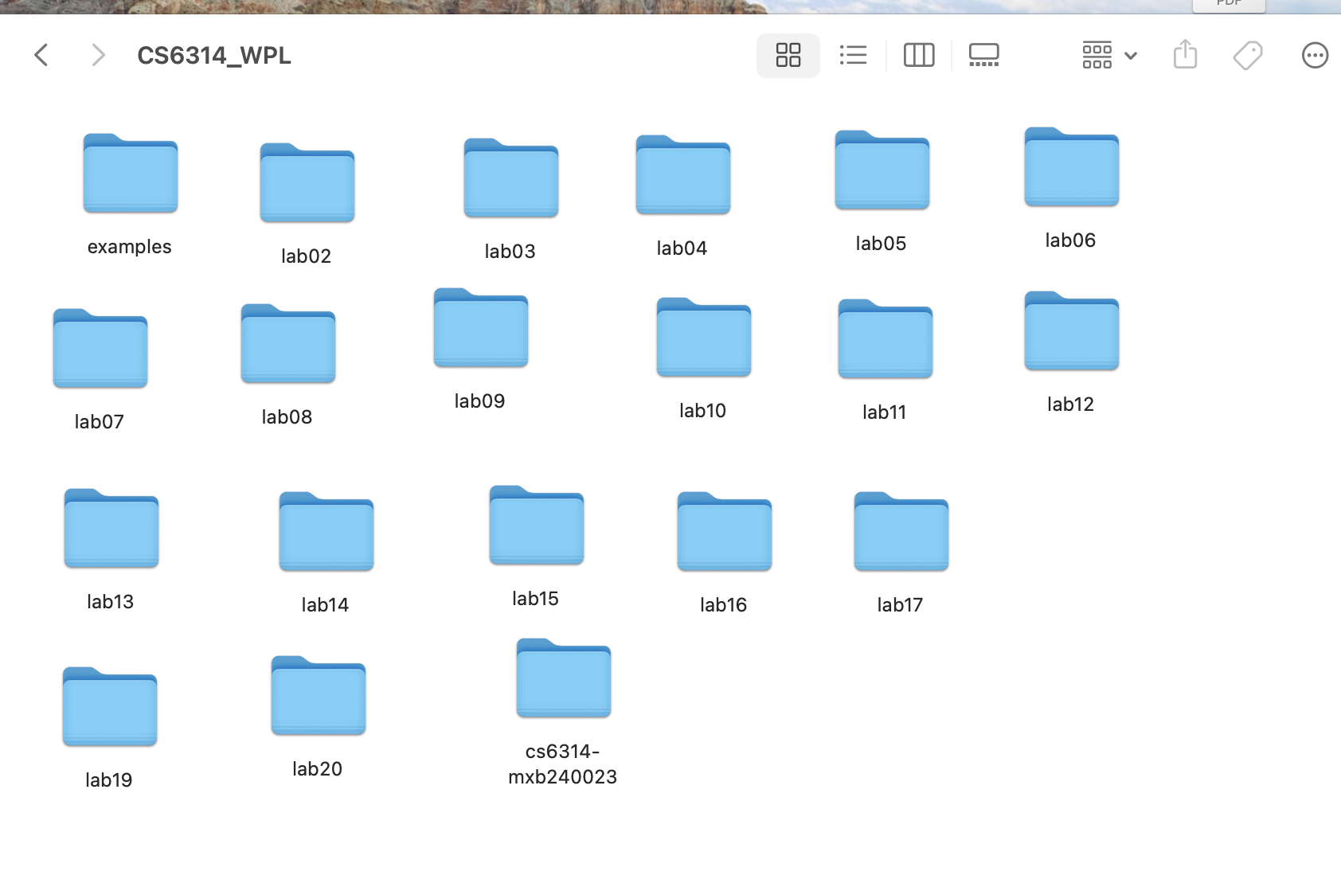

Subfolder with Task5 has been created

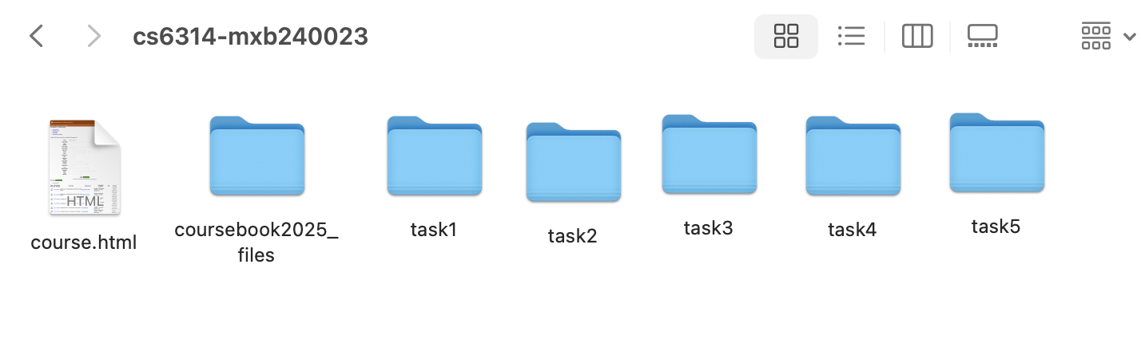

**(1) Design and Implement Tables**

Two tables:

* user: stores user information (like name, email, password, type, status)
* userlog: records each login and logout with timestamps and session ID

1. User table contains user information:

id# (auto)

userid

password (encrypted)

user type (admin or user)

user status (active, inactive, revoked, deleted)

first name

last name

email

create-date&time

last-update date&time.

1. Userlog table contains user log information (each time of login):

id# (auto)

userid

login date-time

logout date-time

session-id.

(2) Administrator runs an initial php script (e.g., setusers.php) to add one admin user and one normal user (as shown below) and use the following users for your test cases. The encrypted password is kept in the table.

Administrator will run an initial php script (setusers.php) to add initial users.

|  |  |  |  |  |  |  |  |
| --- | --- | --- | --- | --- | --- | --- | --- |
| ID# | User Type | User Status | User name | UserID | Password | Email ID | created - Date & Time |
| 1 | admin | active | Admin Name1 | admin1 | admin1 | admin1@utdallas.edu | 2025-03-10 15:30:00 |
| 2 | user | active | User Name2 | user2 | user2 | user2@utdallas.edu | 2035-03-11 09:10:01 |

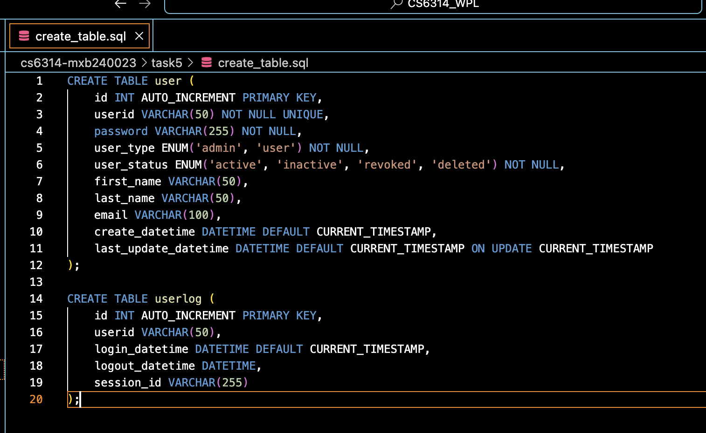

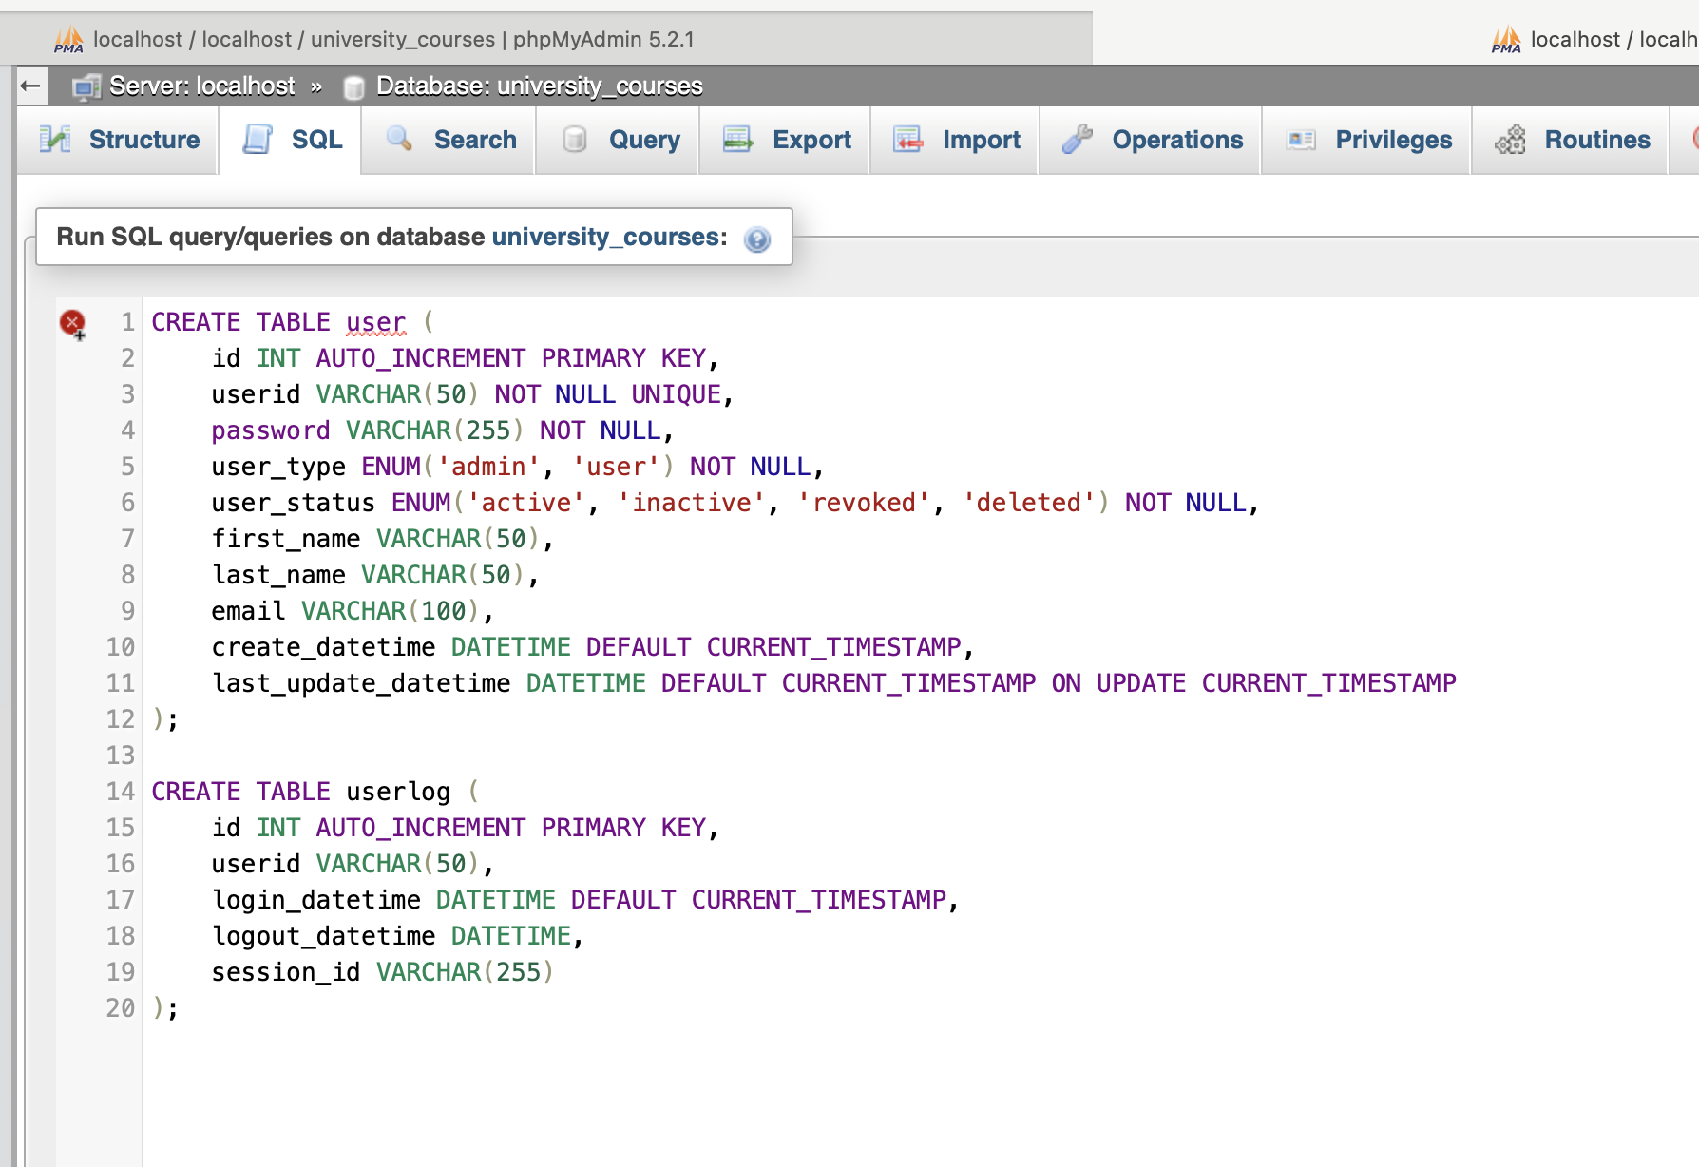

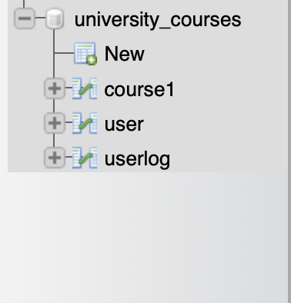

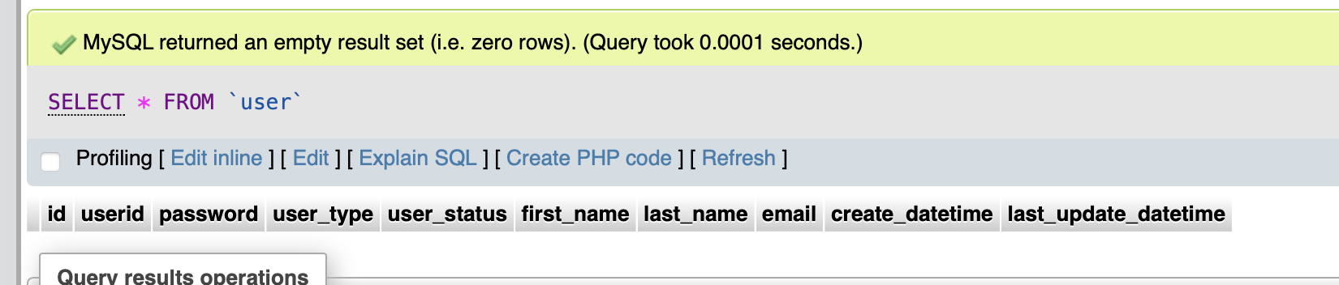

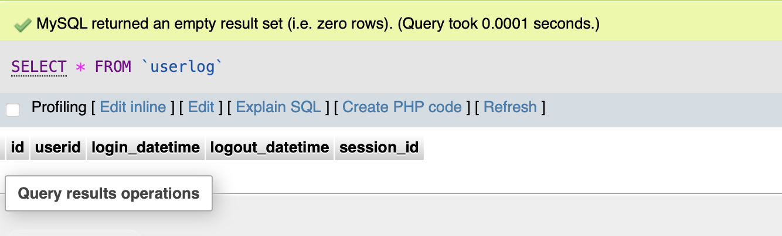

A script that adds **initial 2 users** (one admin, one user). You’ll use password_hash() for the passwords.

You'll insert those two into the user table.

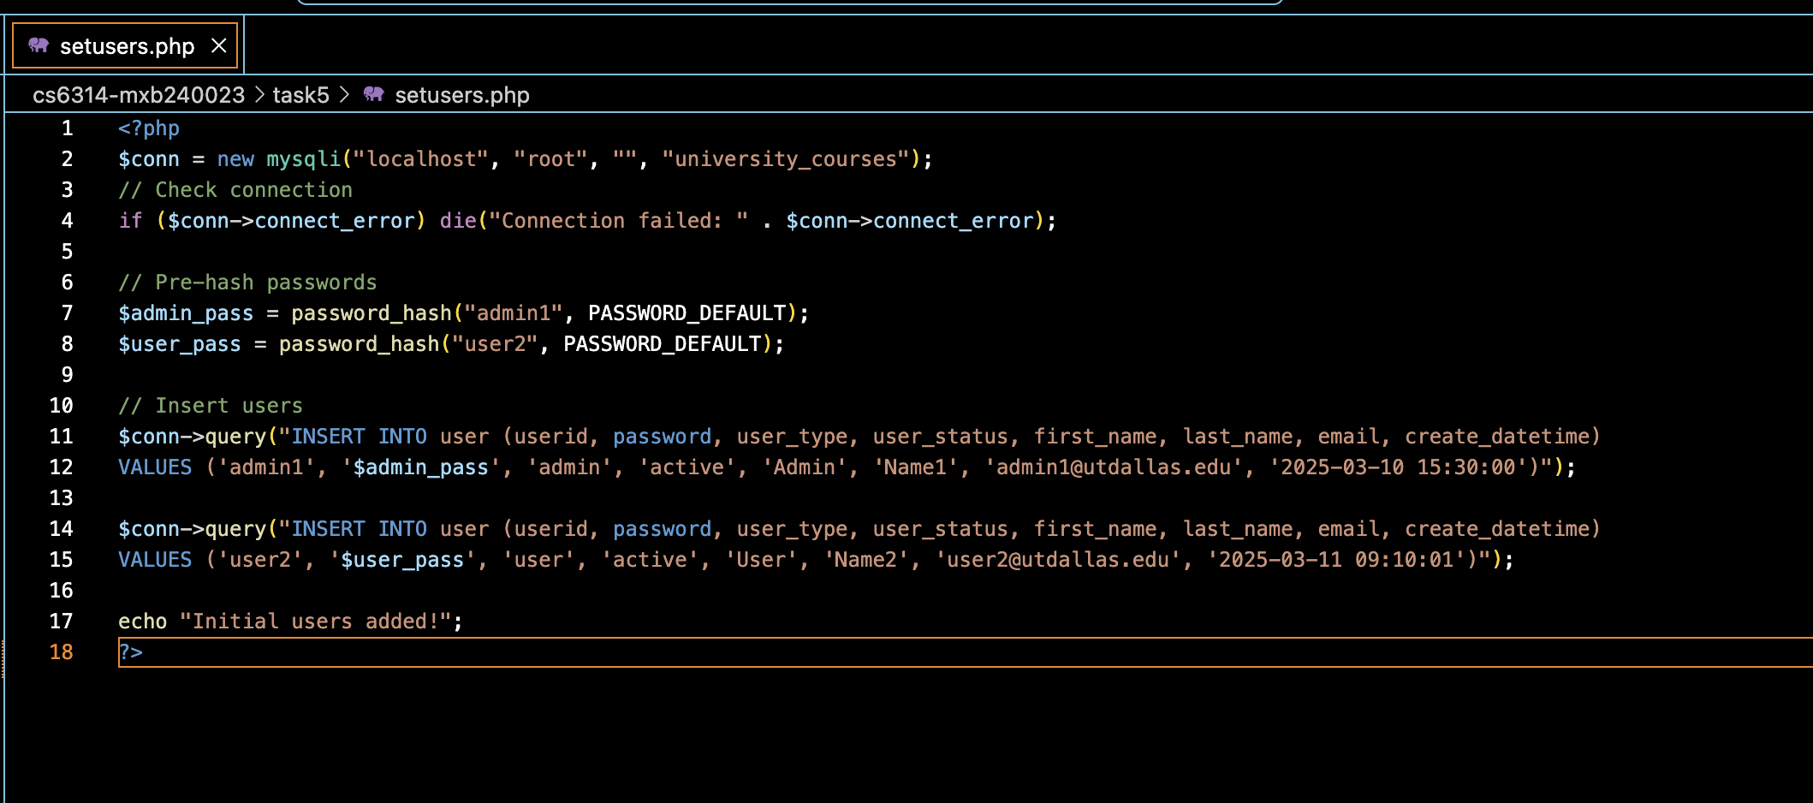

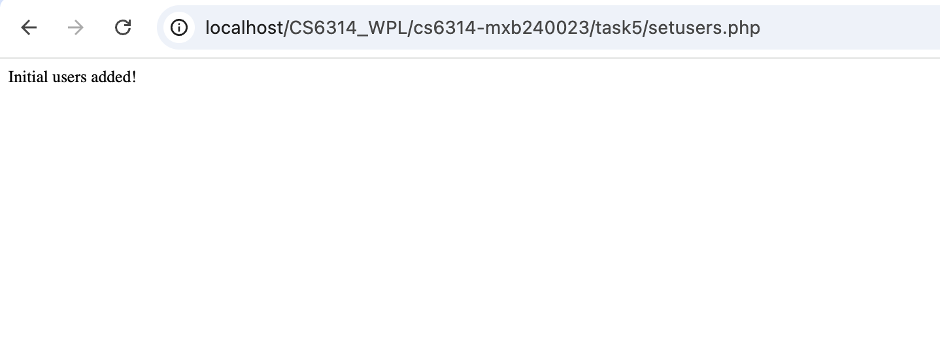

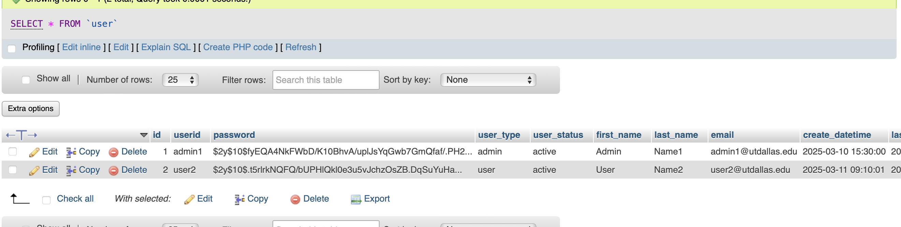

(4) Log-in & Log-out: Provide the log-in and log-out functionalities for a user (active), along with database table for user information. One may log in as an ordinary user to see the main menu of course management (list, search, add, delete, update). One may log in as an administrator to see the administrator main-menu to manage users (to add, delete, update user info). Here an administrator can update user status to be one of active, inactive, deleted, revoked (when failing log-in three times or more), or to be initial status (when user signed up for first time).

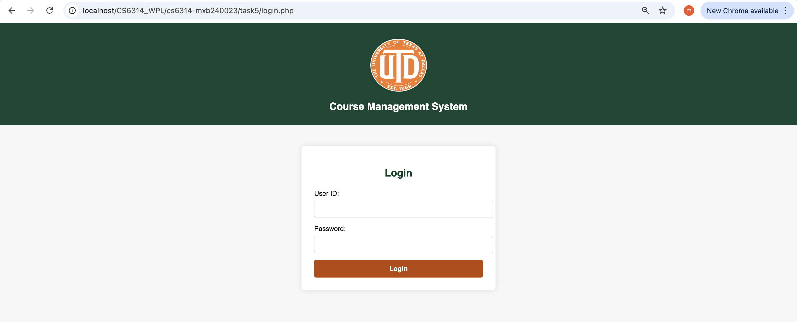

Logging in as admin:

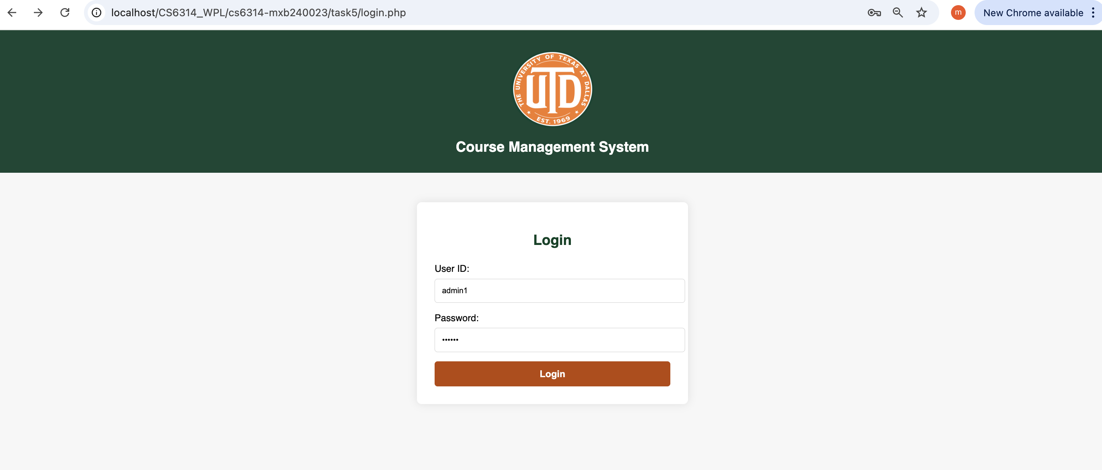

It goes to admin_dashboard.php



manage users (to add, delete, update user info).

can update user status to be one of active, inactive, deleted, revoked (when failing log-in three times or more), or to be initial status (when user signed up for first time).

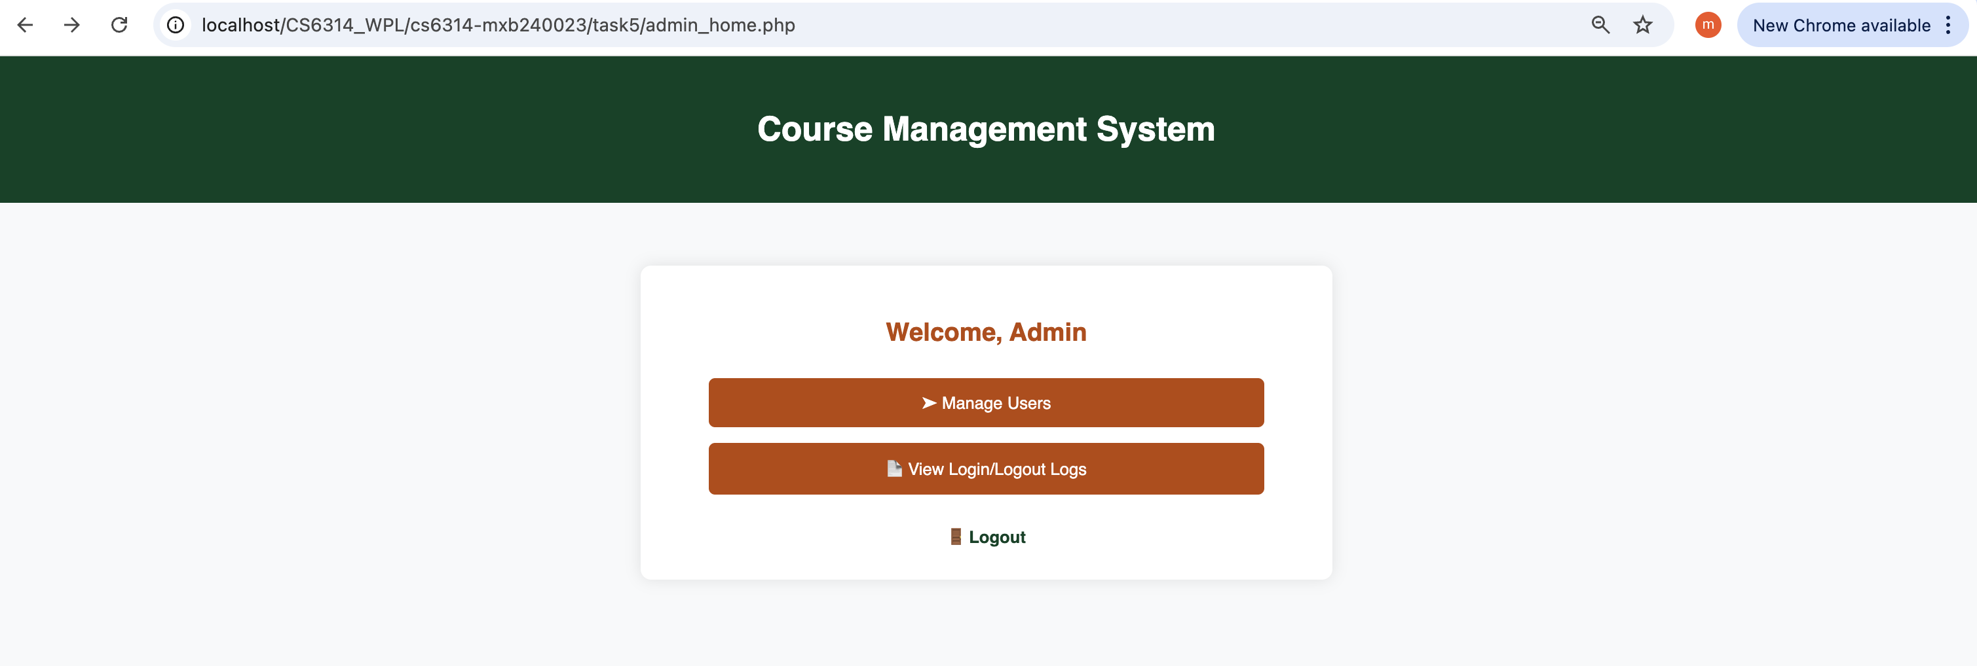

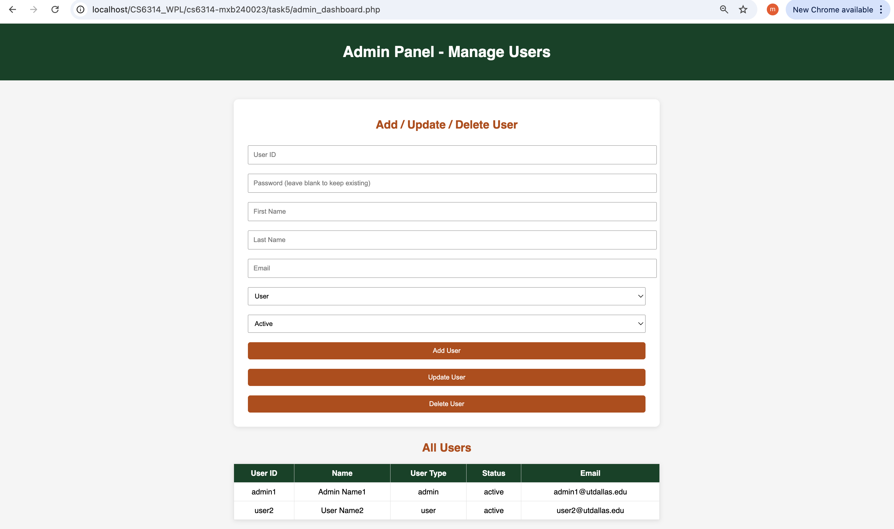

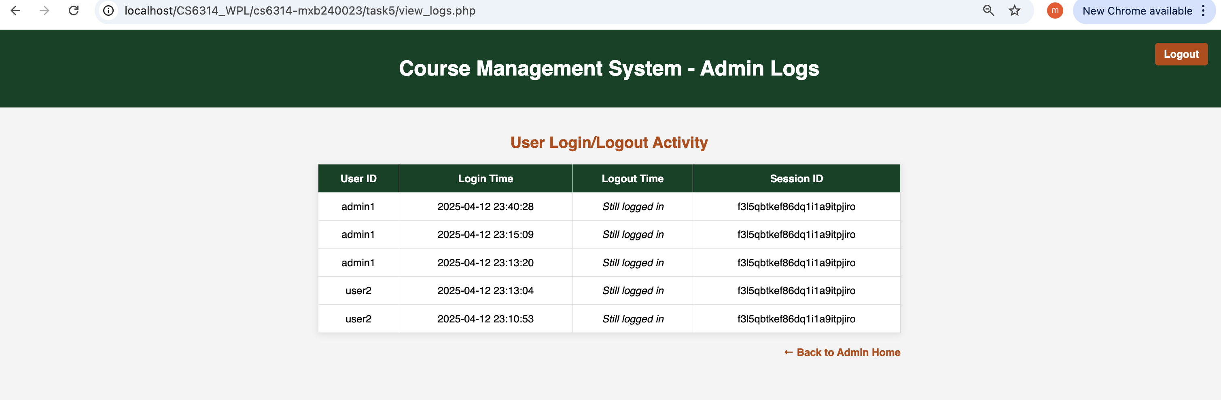

(3) Provide a web page for admin user (once log-in) to add, update, delete user(s) to add the following users:

|  |  |  |  |  |  |  |  |
| --- | --- | --- | --- | --- | --- | --- | --- |
| 3 | User | active | User Name3 | user3 | user3 | user3@utdallas.edu |  |
| 4 | User | active | User Name4 | user4 | user4 | user4@utdallas.edu |  |
| 5 | Admin | active | Admin Name5 | user5 | user5 | admin5@utdallas.edu |  |

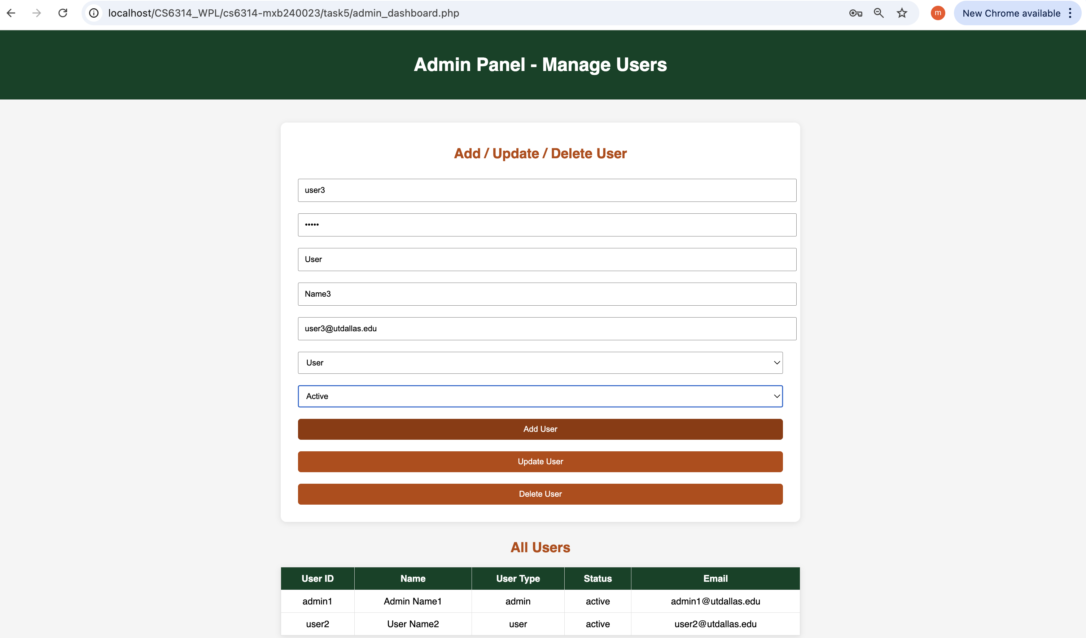

Under All users we can now see user3

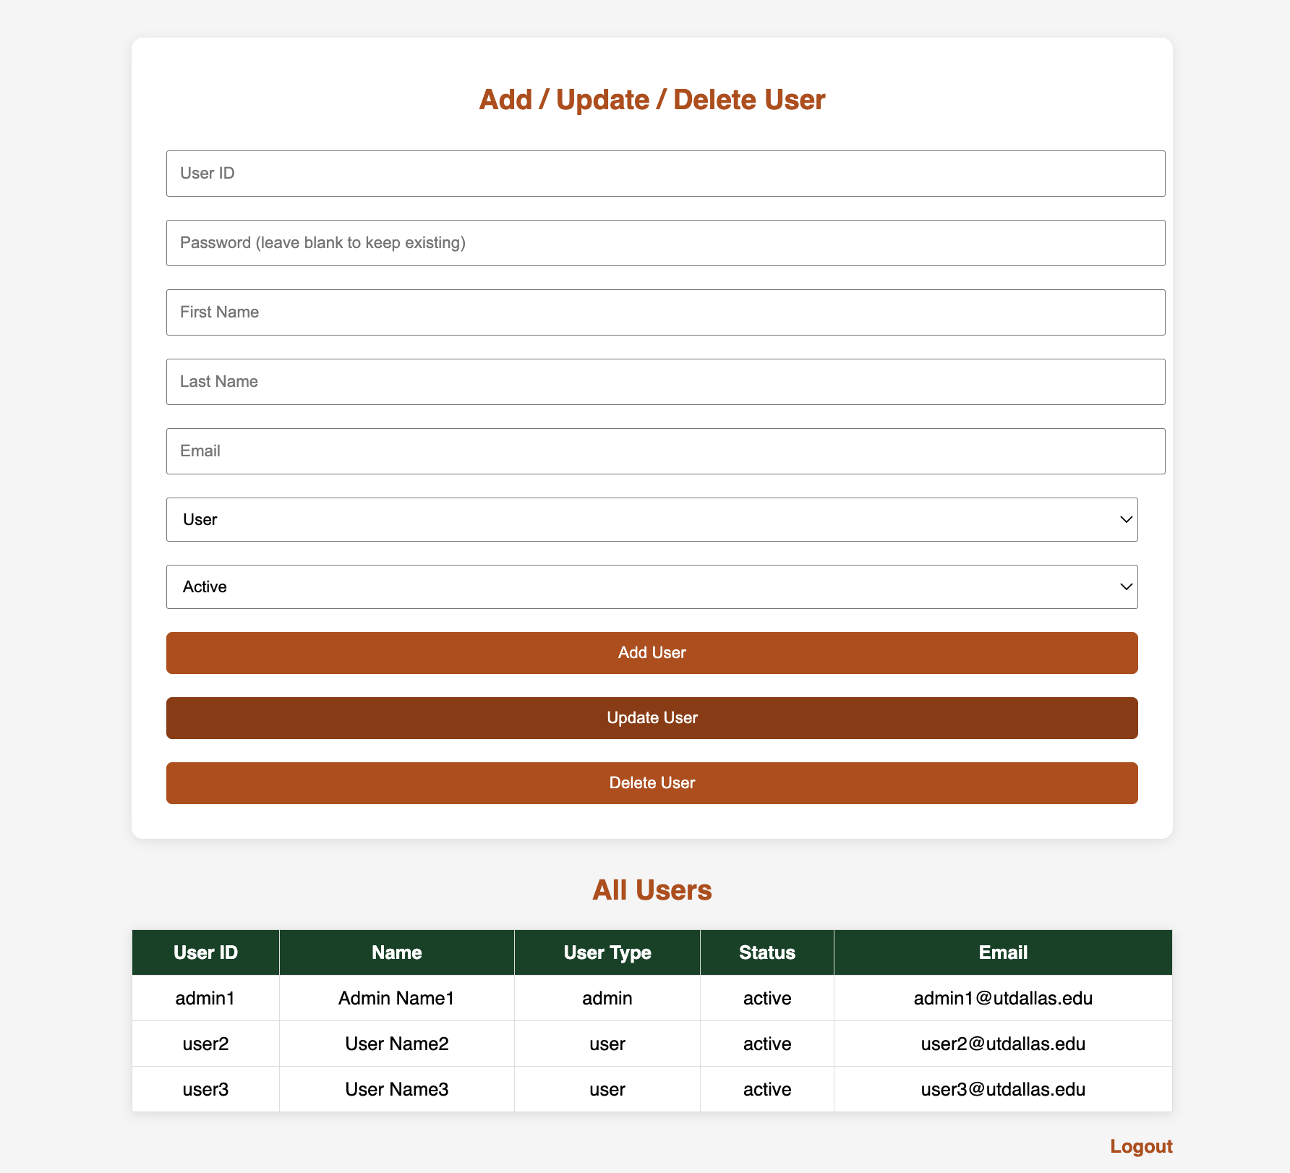

After adding 2 more users  
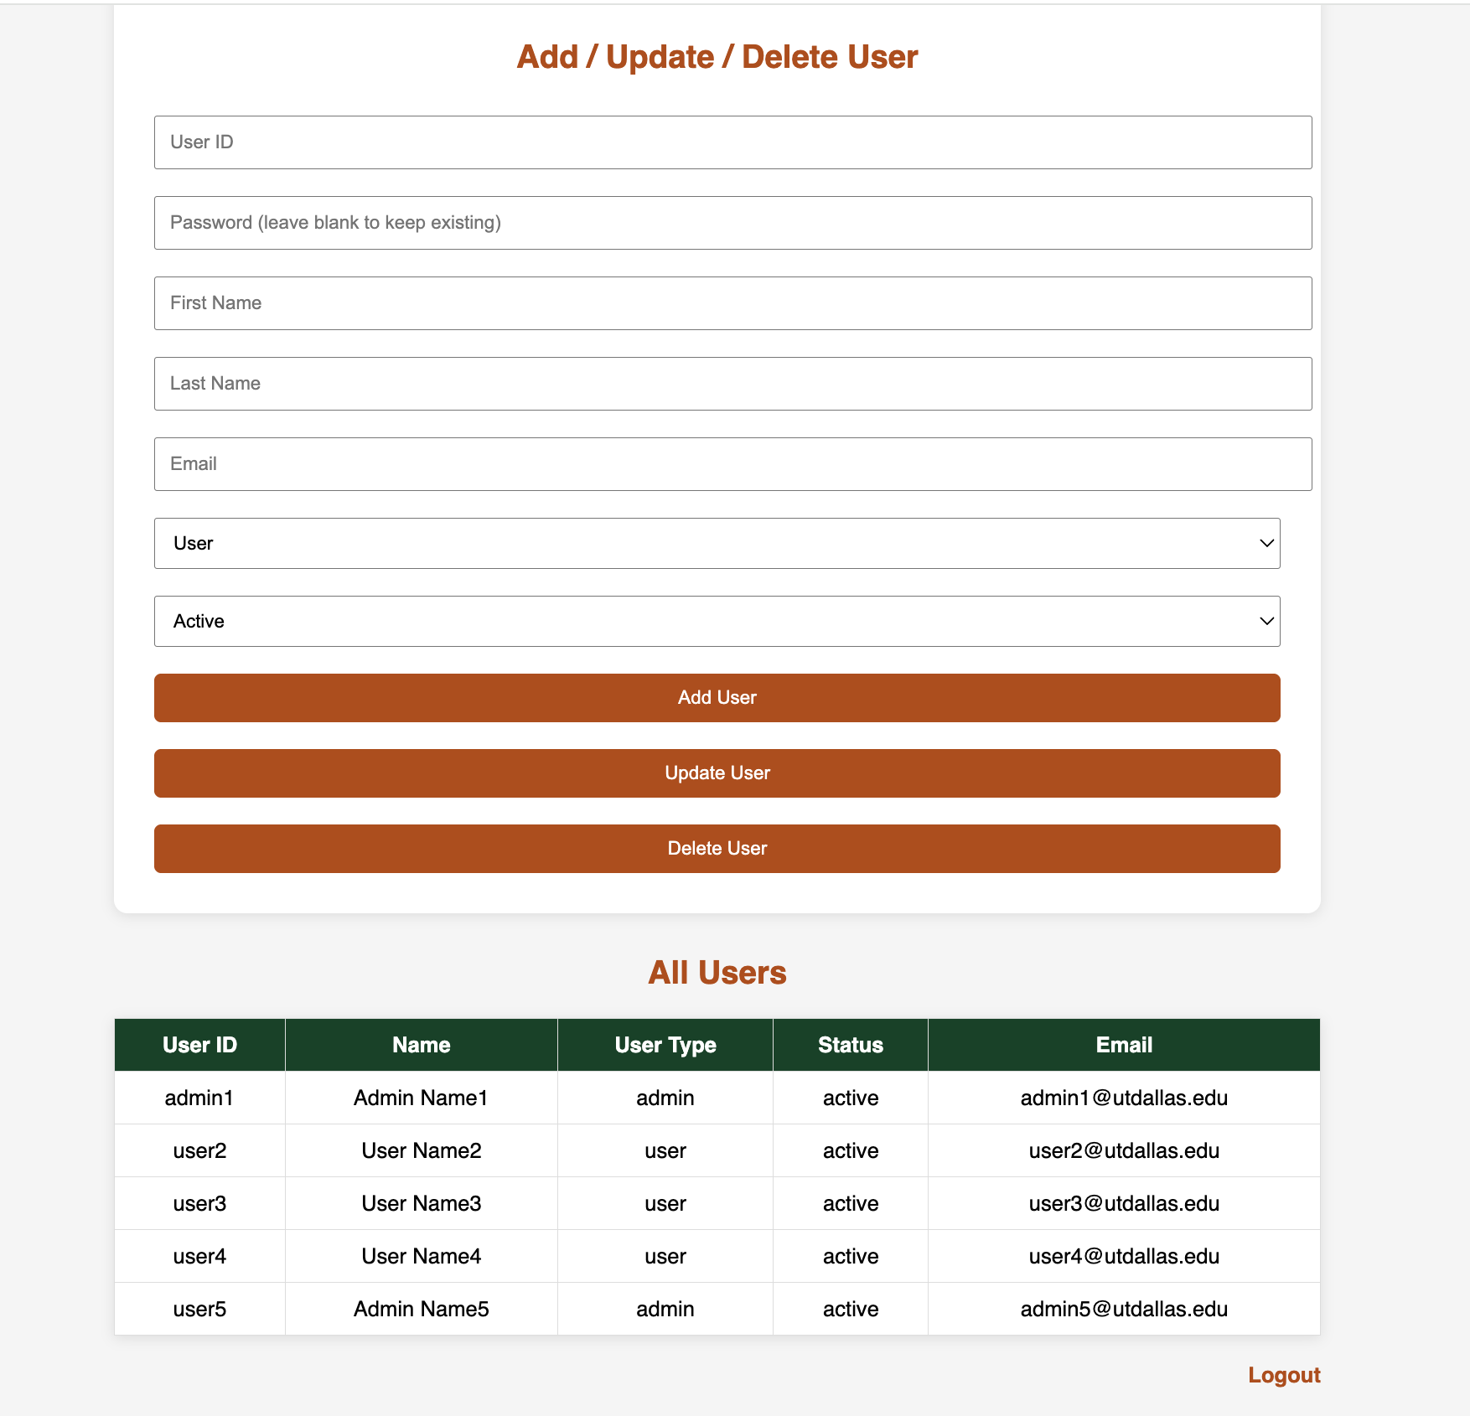

Updating user5 to inactive

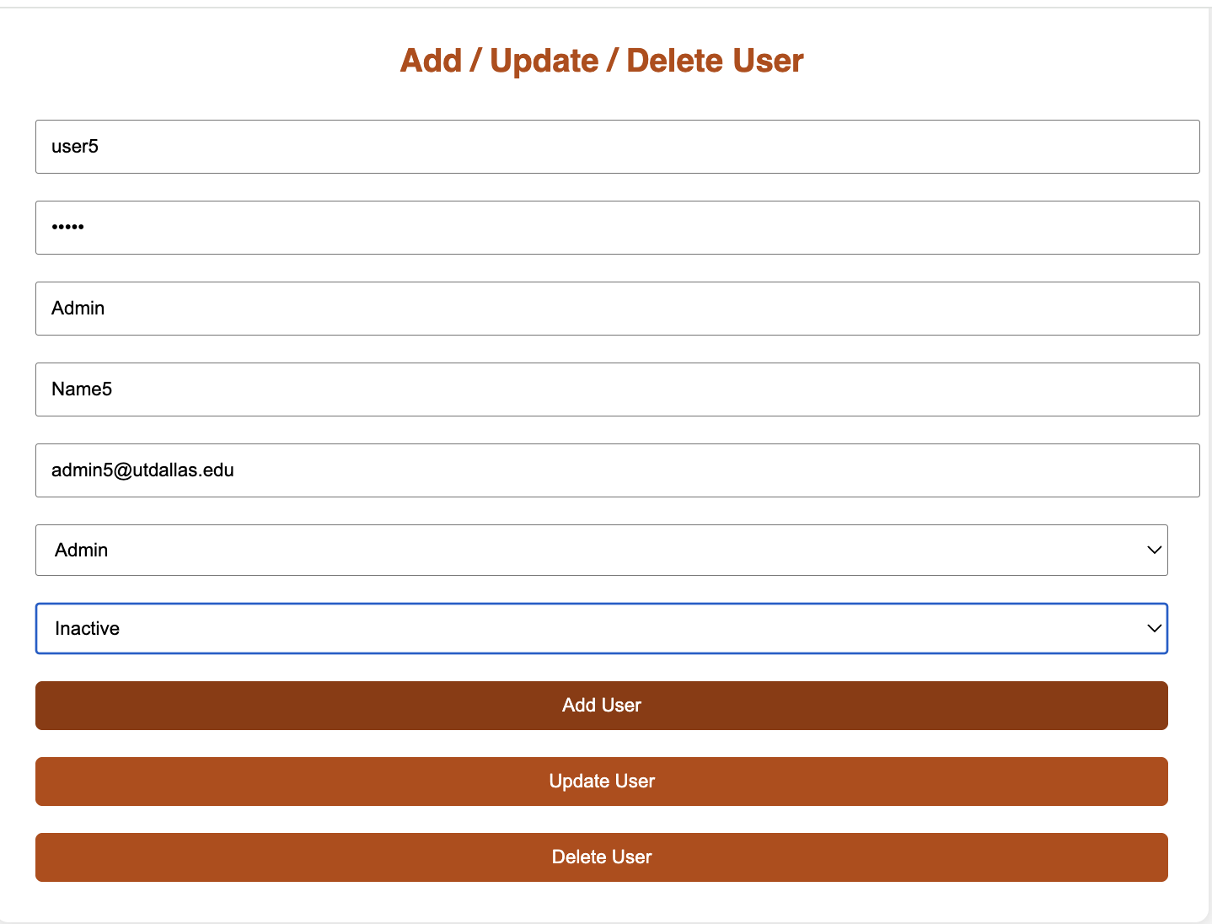

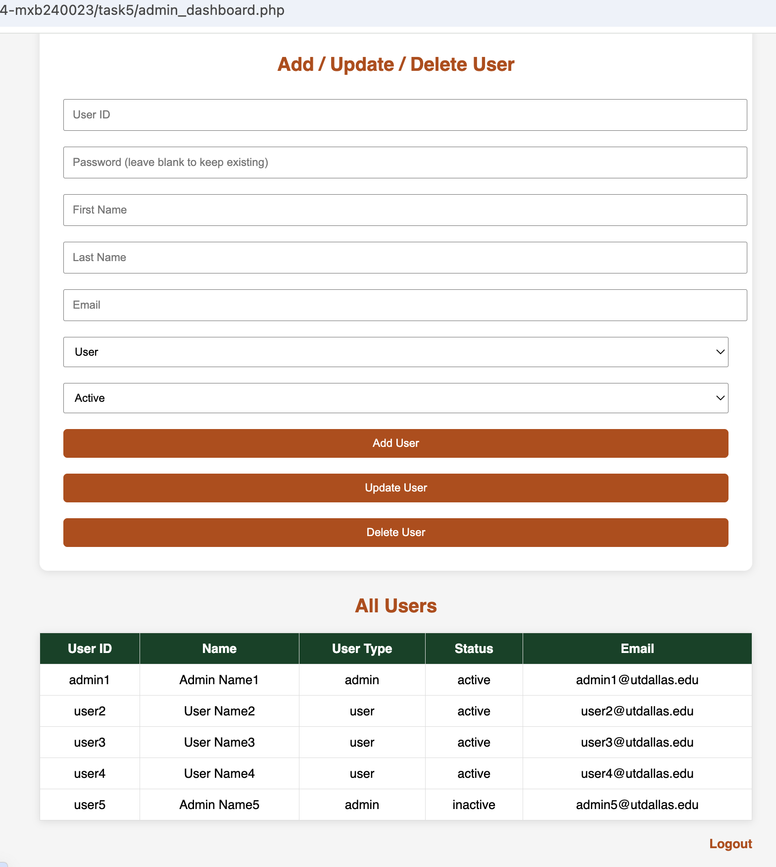

Deleting user5

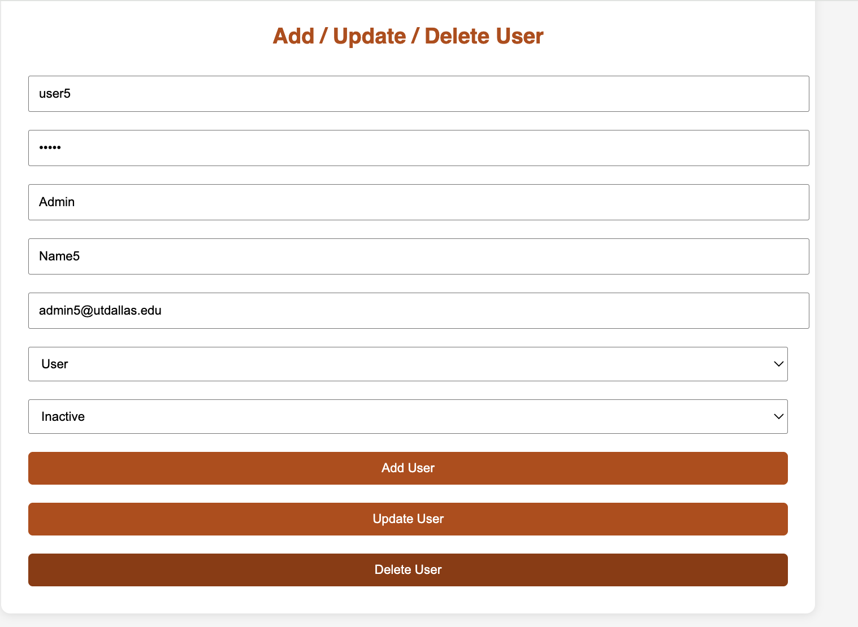

User5 is no longer seen under all users

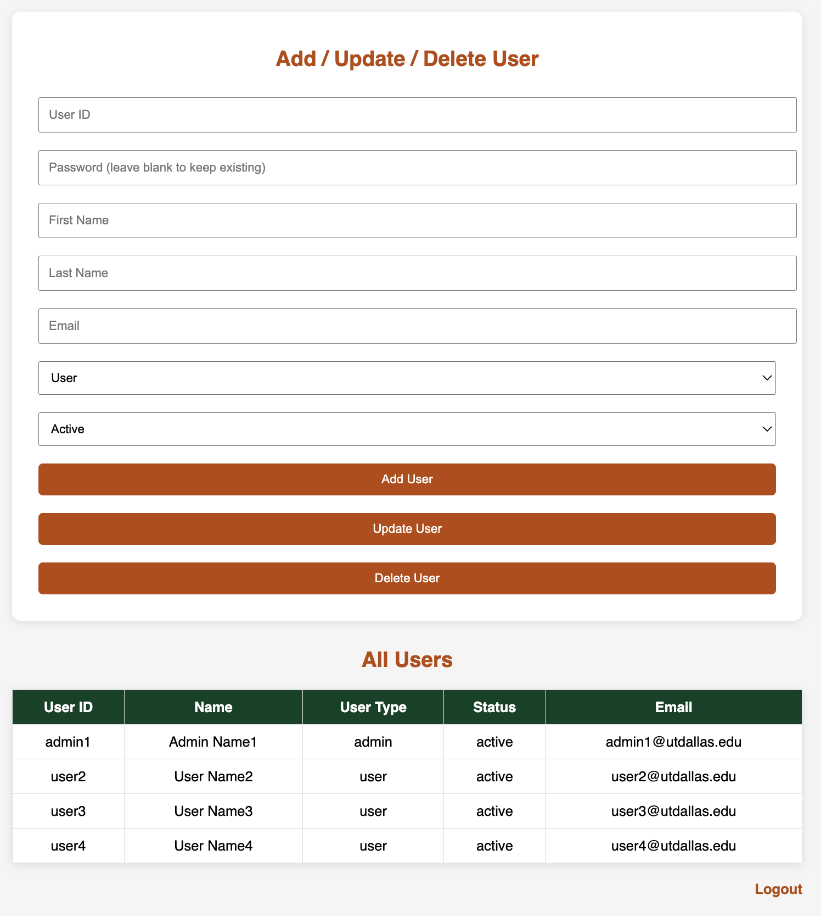

Logout.php:

• Looks up the current user and session.

• Updates their logout time in the userlog table.

• Clears everything and ends the session.

• Redirects with a flag that shows the "Logout successful" message in login.php.

When an ordinary user logs in correctly this is the page that will show up

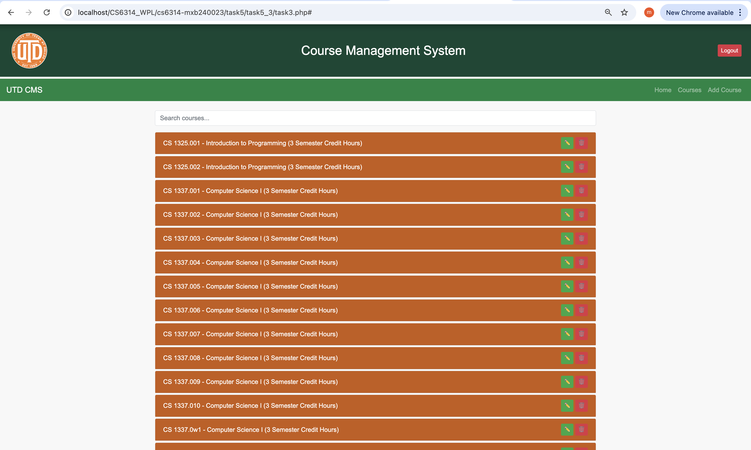

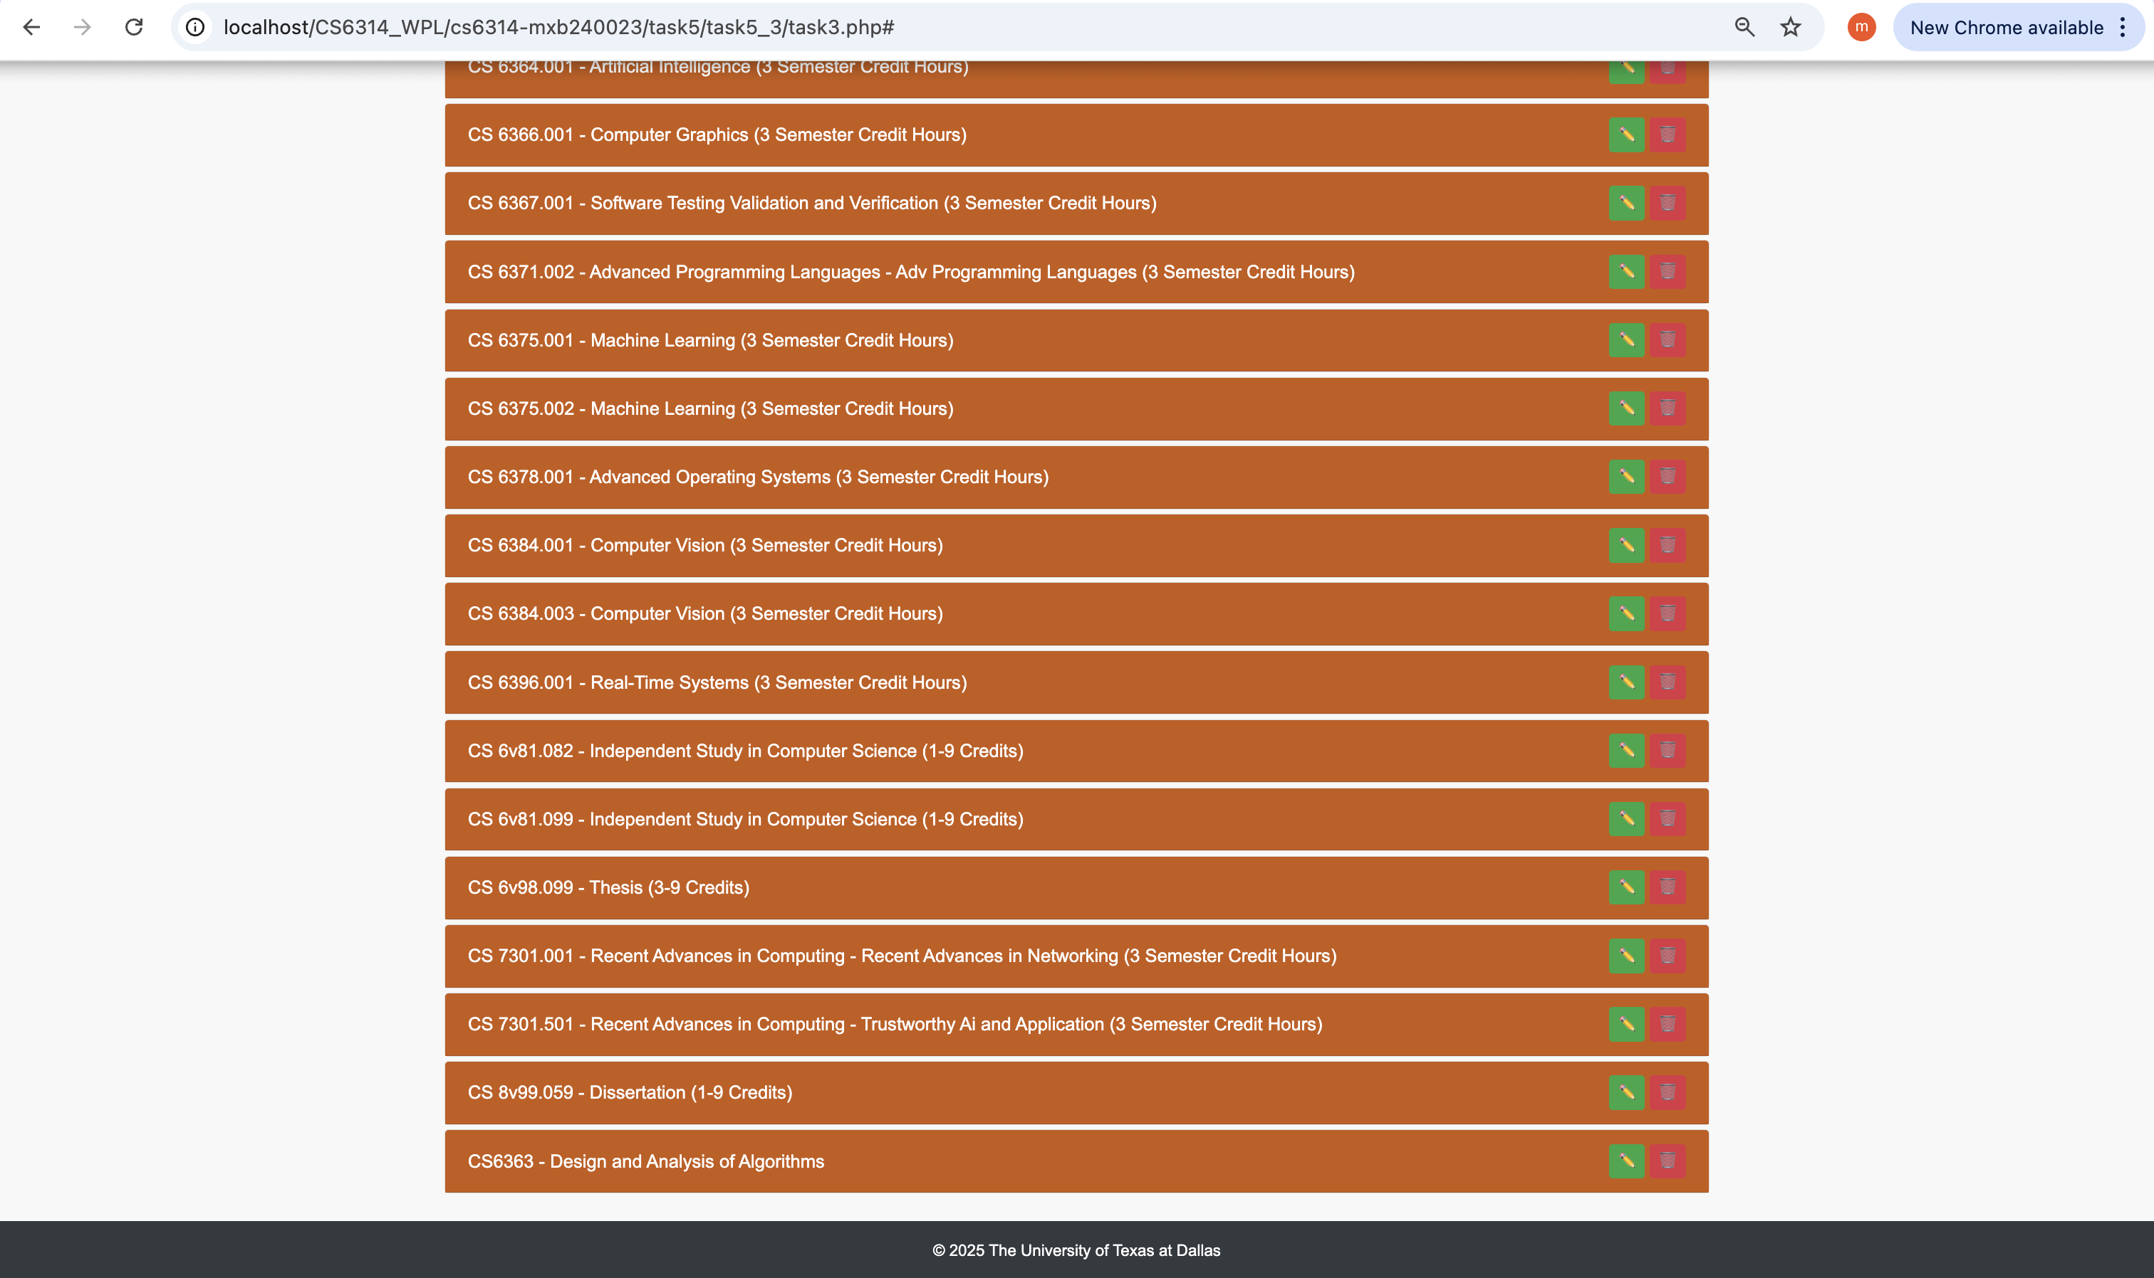

Updating a course:

Updating the course timings

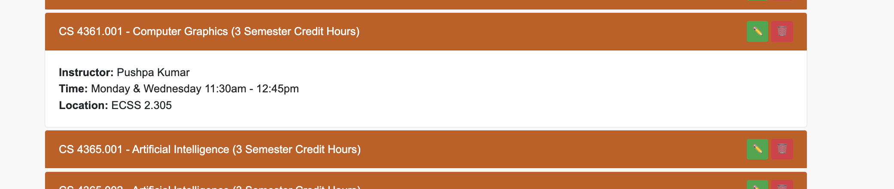



Changed the time

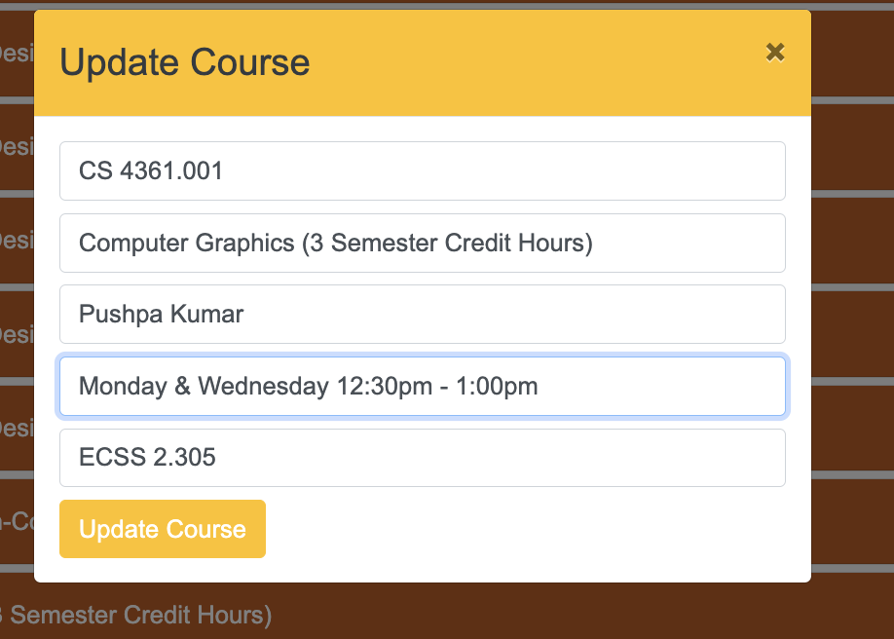

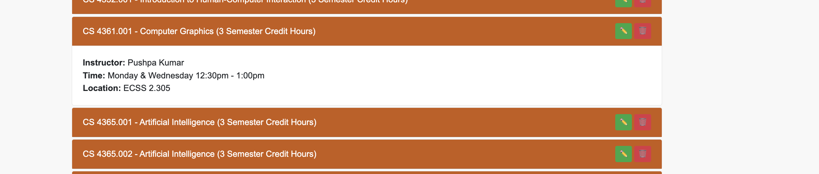

Adding a course:

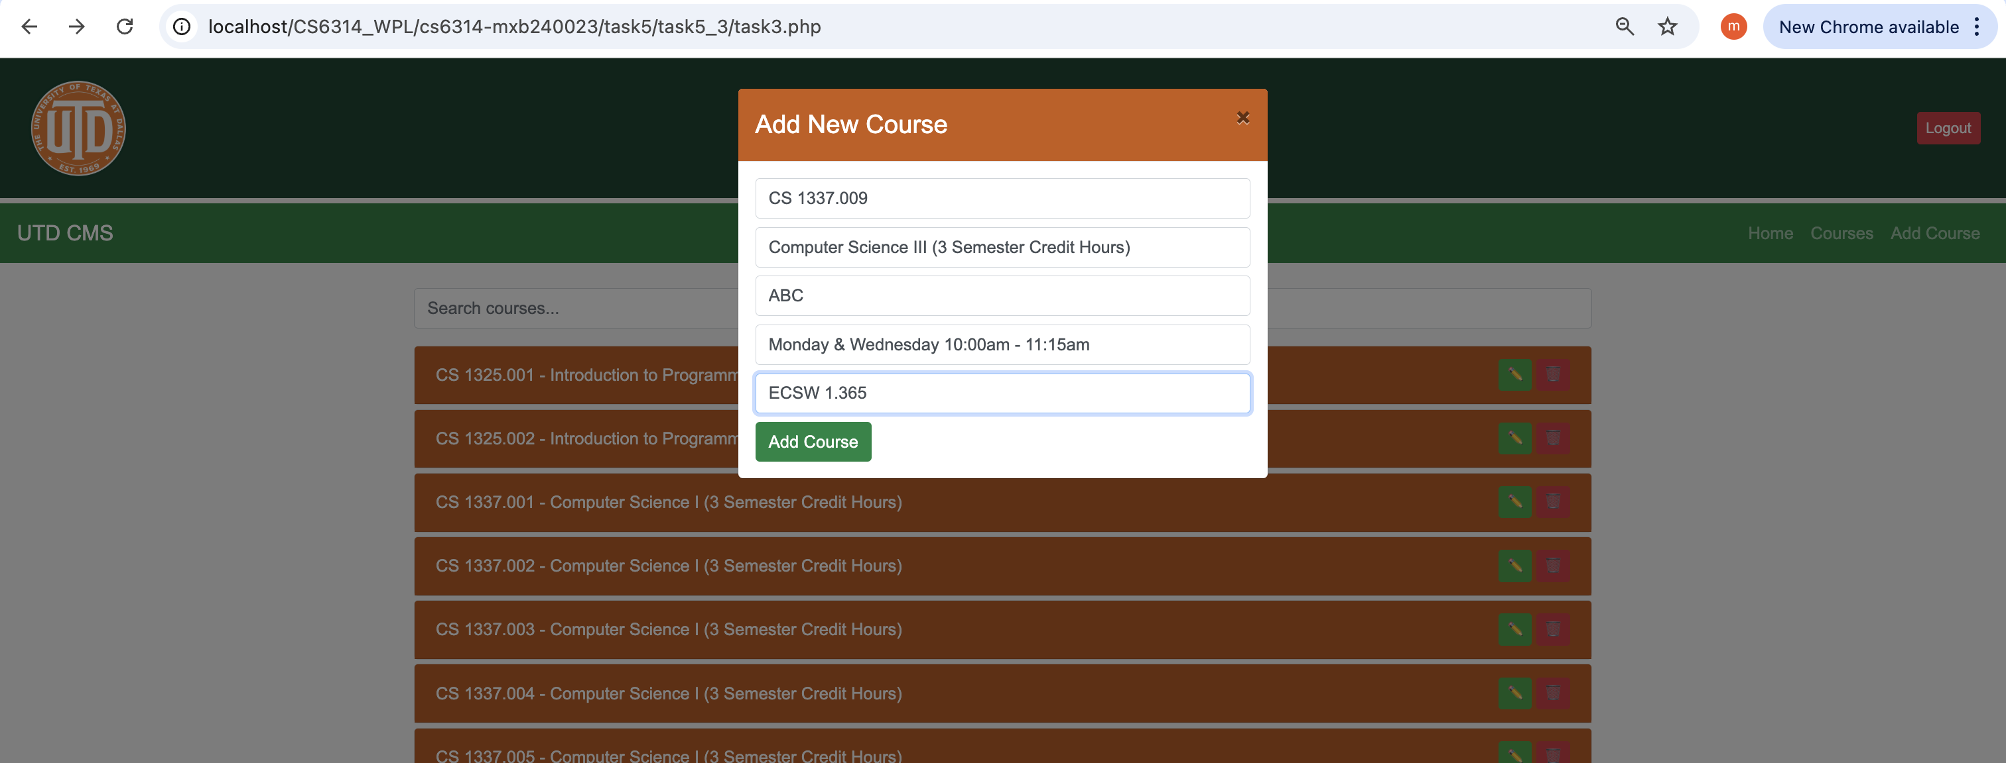

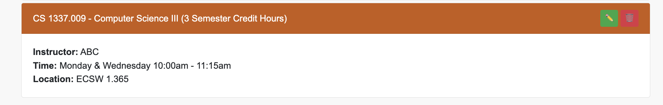

Deleting a Course:

Deleting this course

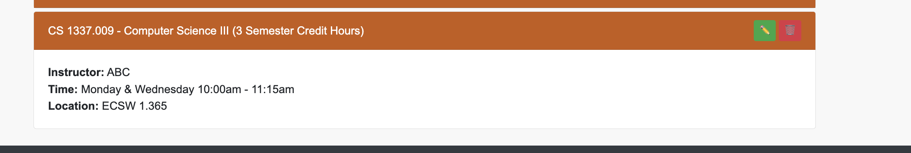

Press on the delete icon

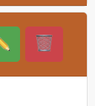

Asks for confirmation

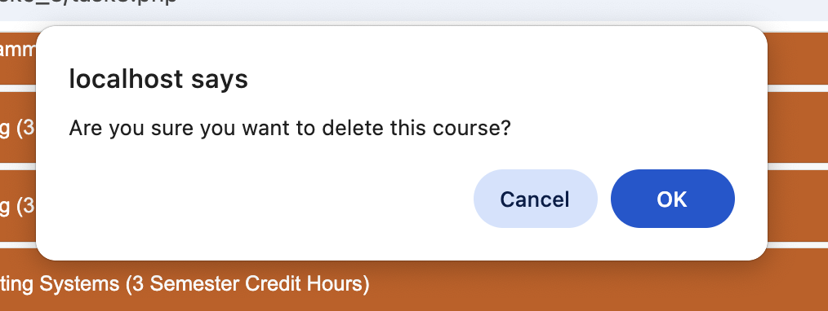

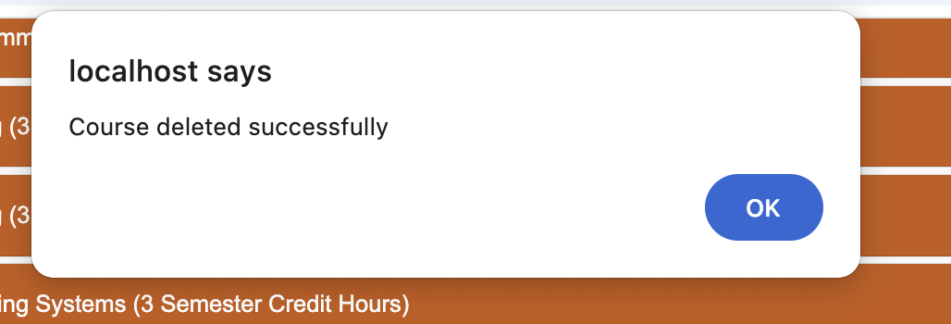

Course has been deleted

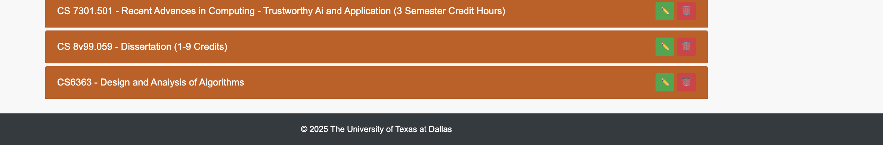

Ordinary user Logging out:

The user id is user2

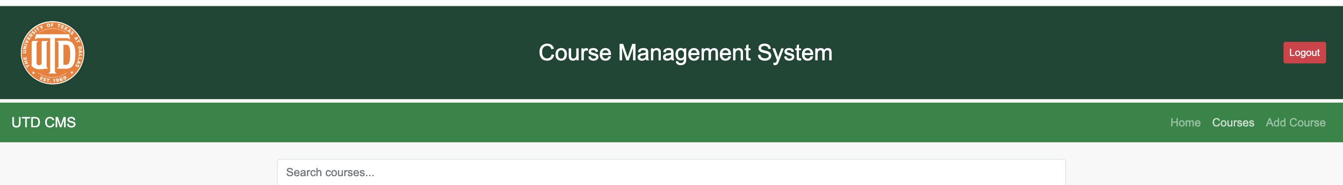

It comes back to the login page:

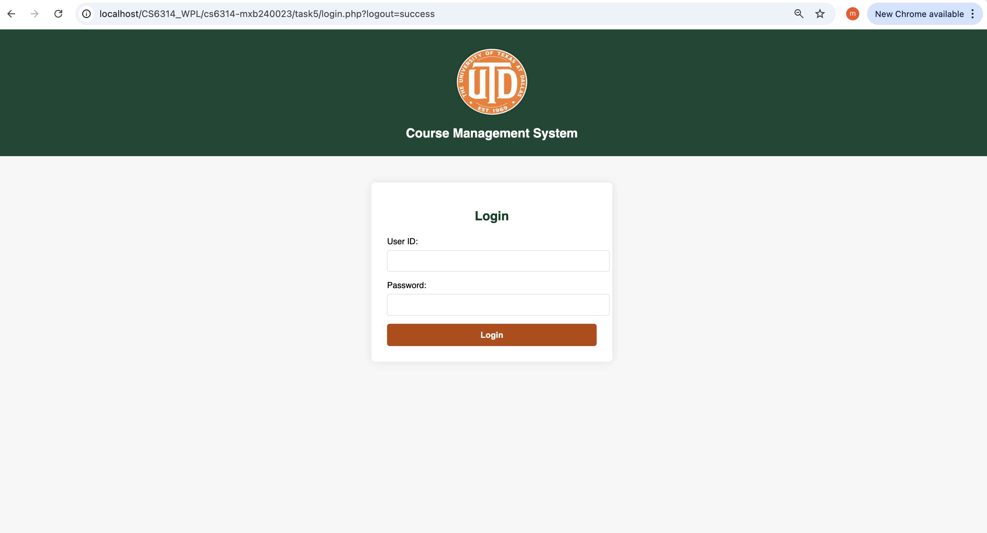

So if an admin logs in and checks we can see that the user2 has been logged out

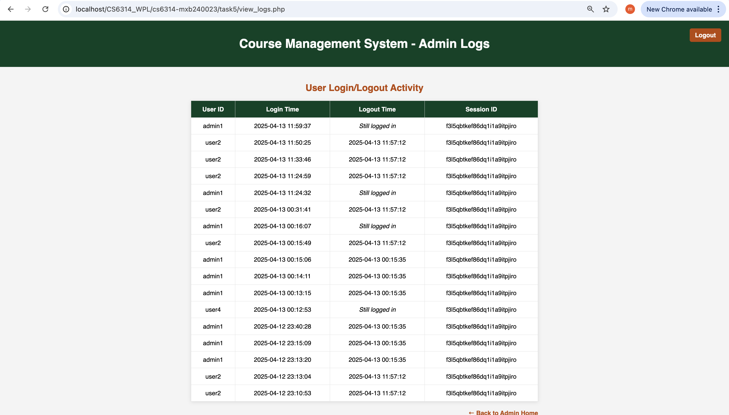

When user failed its log-in step, let user try it for second or third time. If it is failed more than third time, make the userid to be blocked (status to be revoked).

There is an active admin2 user let us verify that if he failed more than 3 times what happens:

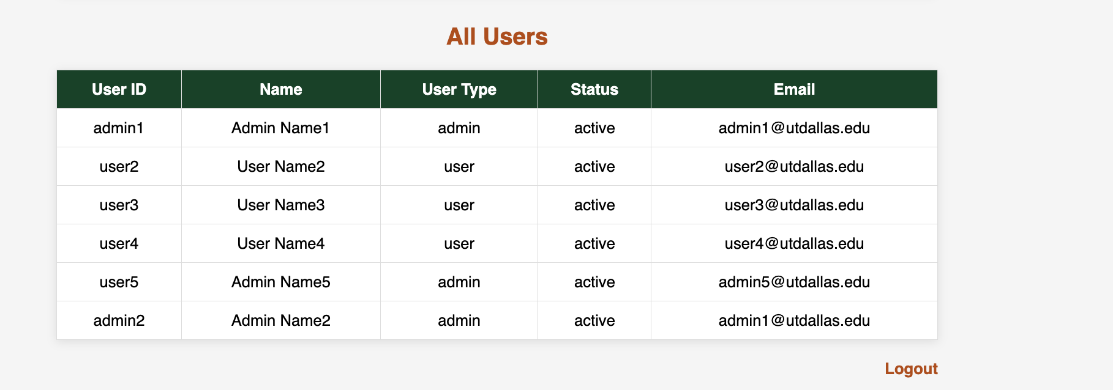

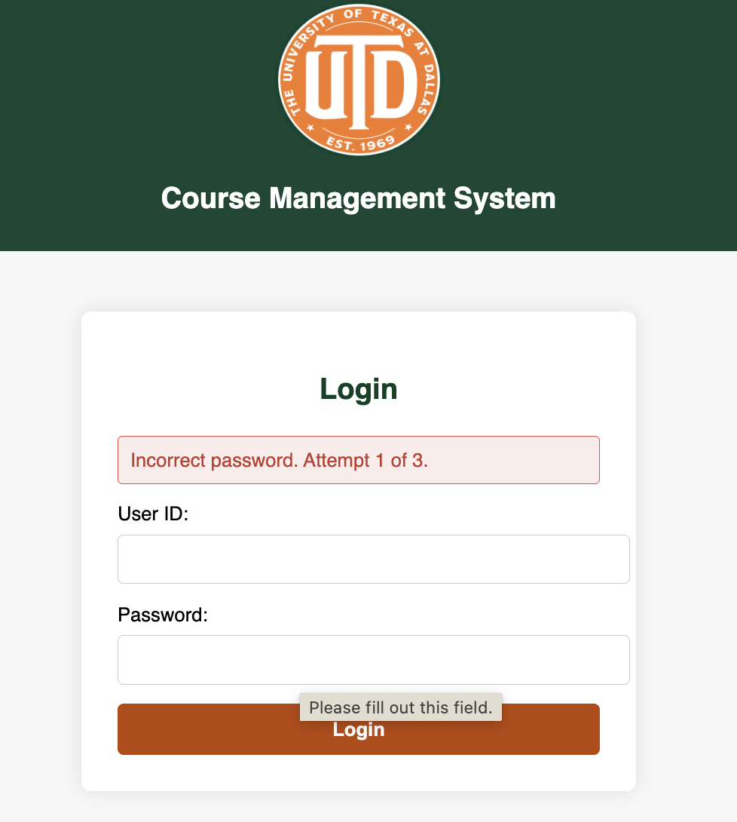

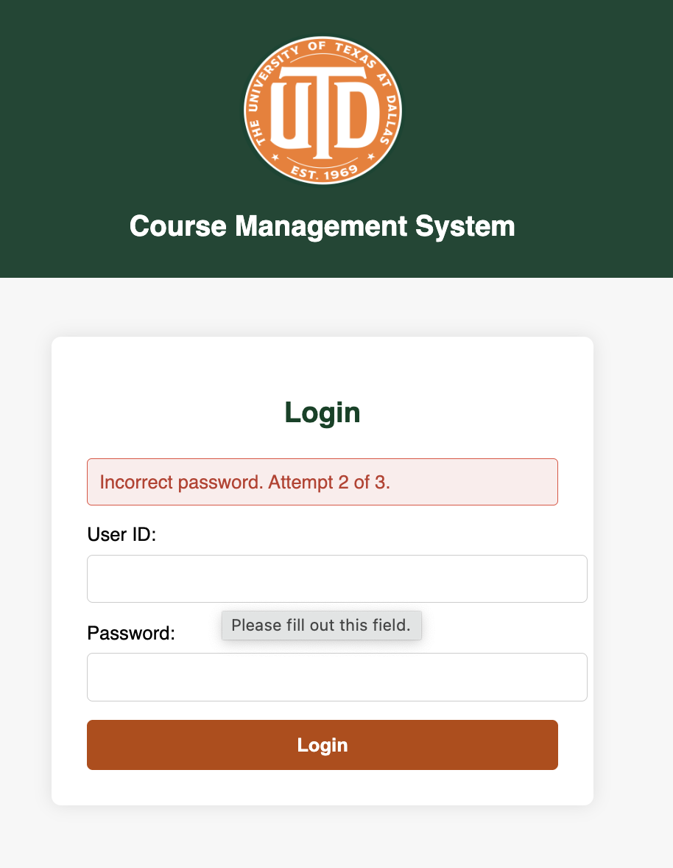

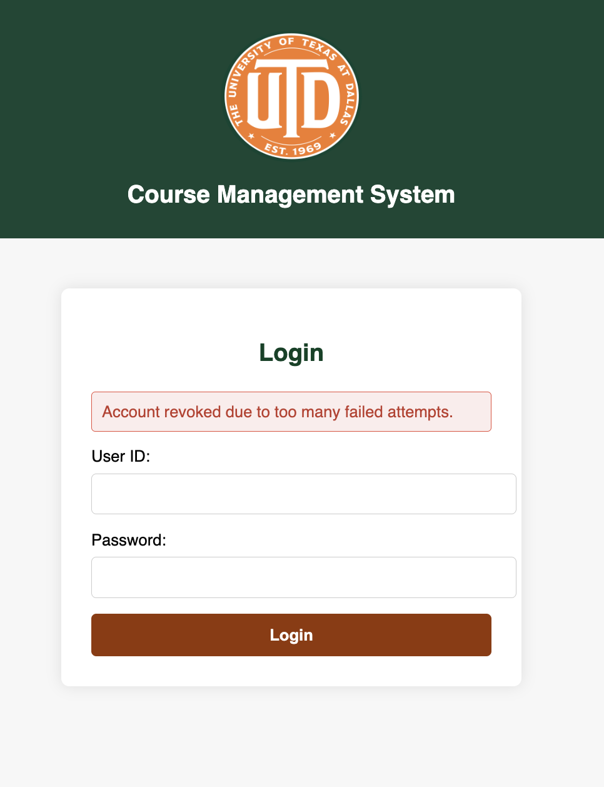

So when I logged in as admin1 and checked the status of admin2 we can see it has been revoked.

